Name: Eyad Mohamed Abdelmohsen Ghanem
Assignment 2
Question 1
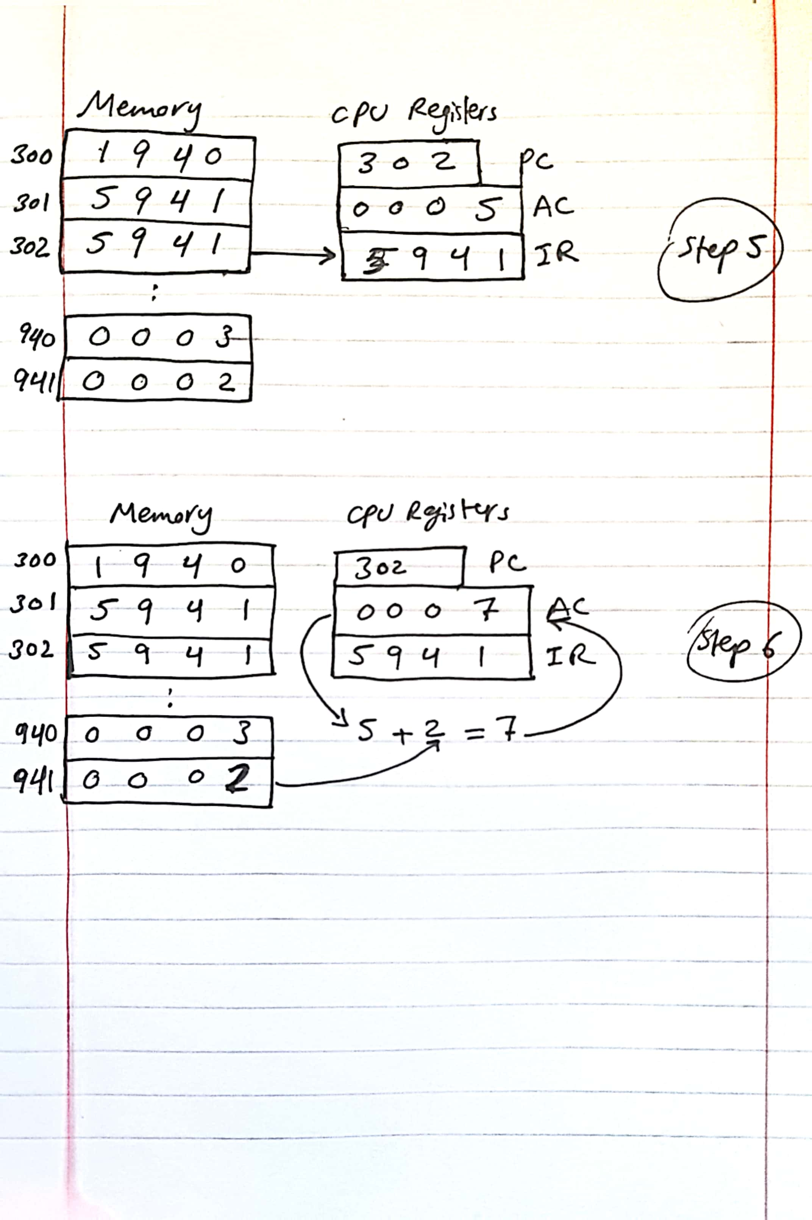
Question 2
Load A:
Move A into MAR.
Send a read signal to memory.
Move data from MDR to one of the microprocessor registers.
Add B, A:
Move B to MAR.
Send a read signal.
Move B to the ALU input, send add bits to the ALU.
Move output through the accumulator to one the CPU registers.
Move A to MAR.
Send a read signal.
Move A to the ALU input, send add bits to the ALU.
Move output through the accumulator to one the CPU registers
Write C:
Move C into MAR.
Send write signal to memory.
Move data from MDR to the memory location C.

Question 3
• Fetch means bringing the opcode from memory and decoding it into machine code through the IR.
• Execute means executing the previous opcode upon the operand
• Fetch deals with opcode only, while Execute deals with operands
• In a fetch cycle, Program Counter (PC) holds address of next instruction to fetch, then Processor fetches instruction from memory location pointed to by PC, then Increment PC, then Instruction loaded into Instruction Register (IR), Processor interprets instruction and performs required actions
• In an execute cycle, data is transferred between CPU and main memory, or between CPU and I/O units, some arithmetic or logical operation on data could happen.

Question 4
1. Hardwired Computer Board
Computer programmed (or design with a Finite State Machine) circuits that are wired with all signals, main draw back they are inflexible if we want to redesign. Advantages are easy to track and simpler to understand.

2. Micro-coded Computer Board
Computer programmed (or design with a Finite State Machine) circuits that are programmed through a pseudo code and any programming language and embedded in digital devices. Advantages easy to reprogram, but harder to track errors.

